|  |  |
| --- | --- |
| C:\Users\DELL\Downloads\WhatsApp Image 2024-06-05 at 14.37.22.jpeg  **STUDY TOUR REPORT UNDERTAKEN BY THE HUMAN RESOURCE MANAGEMENT OFFICE, HOSTED BY THE KENYA SCHOOL OF GOVERNMENT, NAIROBI – KENYA, FROM 3-7 JUNE, 2024.** |  |

# **TABLE OF CONTENT**

[**TABLE OF CONTENT** i](#_Toc346001836)

[**1.** **INTRODUCTION** 1](#_Toc346001837)

[**2.** **PURPOSE OF THE STUDY TOUR** 2](#_Toc346001838)

[**3.** **DELEGATION OF THE STUDY TOUR** 2](#_Toc346001839)

[**4.** **APPROACH/ METHODOLOGY** 3](#_Toc346001840)

[**4.1.** **Interactive Presentations** 3](#_Toc346001841)

[**4.2.** **Site Visitations** 3](#_Toc346001842)

[**5.** **SPECIFIC AREAS OF INTEREST** 6](#_Toc346001843)

[**5.1.** **Performance Management in Public/Civil Service** 6](#_Toc346001844)

[**5.2.** **Workload Analysis** 6](#_Toc346001845)

[**5.3.** **Strategic Leadership** 8](#_Toc346001846)

[**6.** **CHALLENGES ASSOCIATED WITH THE STUDY TOUR** 9](#_Toc346001847)

[**7.** **LESSONS LEARNT** 10](#_Toc346001848)

[**8.** **RECOMMENDATIONS** 13](#_Toc346001849)

[**ANNEX 1: ACTION PLAN** 15](#_Toc346001850)

[**ANNEX 2: PROGRAMME OF THE STUDY TOUR** 19](#_Toc346001851)

[**ANNEX 3: ATTENDANCE LIST** 21](#_Toc346001852)

[**PHOTO PAGE** 22](#_Toc346001853)

# **INTRODUCTION**

The Human Resource Management Office (HRMO) is the central personnel management agency charged with the responsibility of providing human resource policies and advisory services and also managing the Civil Service workforce to effectively and efficiently deliver services to the Government and people of Sierra Leone. As such, HRMO is required, among other things, to device and introduce HR policies, systems and processes that enable the Civil Service provide better services to the general public and the government, in an efficient and effective manner.

As part of effort to achieve the above, the European Union support to the Government of Sierra Leone through the **“Multi Annual Programme Estimate - Civil Service Reform”** Contract **No.: FED/2019/411-021,** provided for three study tours to be undertaken by the Human Resource Management Office in the following thematic areas: Strategic Leadership, Performance Management and Workload Analysis. These three areas were charged under activity budget lines **3.1.2.4 (**Leadership); **3.2.1.2.2** (Performance Management) and **3.2.1.4 (**Workload Analysis**)**,

Participants of the study tour comprised five (5) senior officers of HRMO led by the Director General as head of the delegation. This activity was undertaken in Kenya from the 3rd to 7th June, 2024, under the auspices of the Kenya School of Government in Nairobi.

The specific focus of the study tour was to benchmark and share experiences with public /civil service operatives in the Kenyan public service in the three thematic areas mentioned above.

# **PURPOSE OF THE STUDY TOUR**

The purpose of the study tour was to:

* Learn best practices and share experiences with regards to managing performance in the Civil/Public Service;
* Gain practical knowledge and skills in conducting workload analysis/staff rationalization for the Civil Service;
* Gather information on how transformational leadership drives organisational reforms and productivity in the Public/Civil Service;
* Visit similar public sector institutions to experience how services are delivered.

# **DELEGATION OF THE STUDY TOUR**

The delegation comprised of the following individuals:

**No. Name** **Designation**

1. Mr. Ansu S. Tucker Director-General
2. Mr. Chernor I. Mansaray Director, Performance Management
3. Mr. Patrick M. Kawa Director, Management Services
4. Mr. Swaray Junisa Deputy Secretary
5. Mr. Saidu Bockarie Deputy Secretary

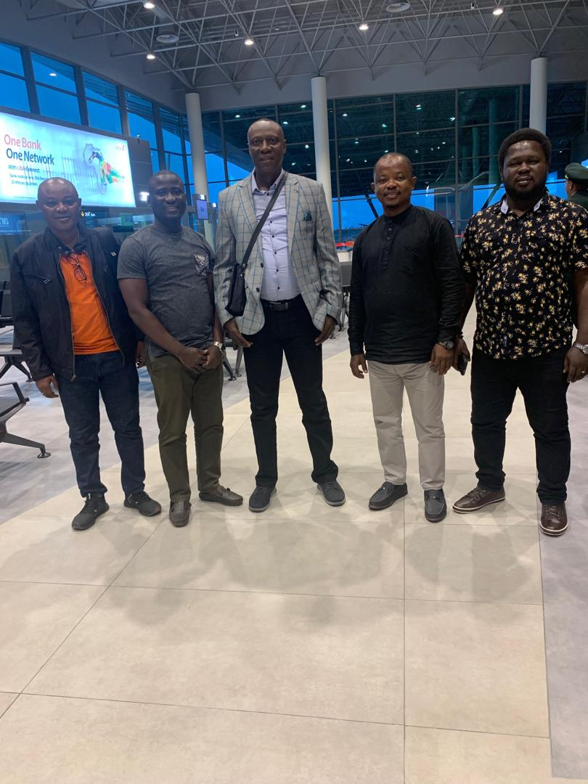

***The Director-General and team at the Departure lounge, Lungi International Airport. Friday 31st May, 2024***

# **APPROACH/ METHODOLOGY**

The study tour was carried out using the following methods:

* 1. **Interactive Presentations**: Power Point presentations were made on key topics of interest under Performance Management, Strategic Leadership and Workload Analysis. These sessions were interactive, educative, informative and thought provoking.

* 1. **Site Visitations**: Three institutions were slated for visitation, and these were: Huduma Centre, Kenya Electricity Generating Company (KenGen) and Public Service Commission, for hands-on experience sharing on the areas of interest highlighted above. The aim of these visits was to create an opportunity to compare notes, understand how their systems and processes are built, reasons for their successes, challenges encountered and how they have been able to surmount those challenges. Nonetheless, the delegation was only able to visit Huduma centre in Nairobi due to challenges related to change in schedule and competing priorities.

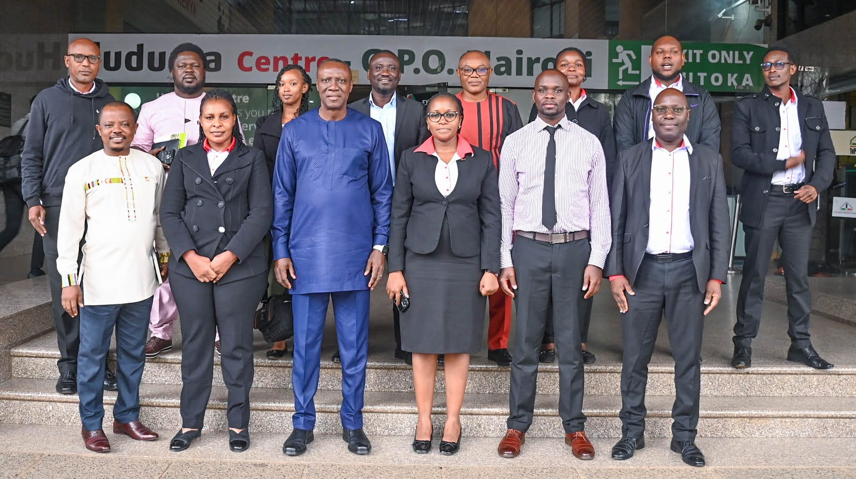

***The Sierra Leone Delegation and Staff of the Huduma Centre***

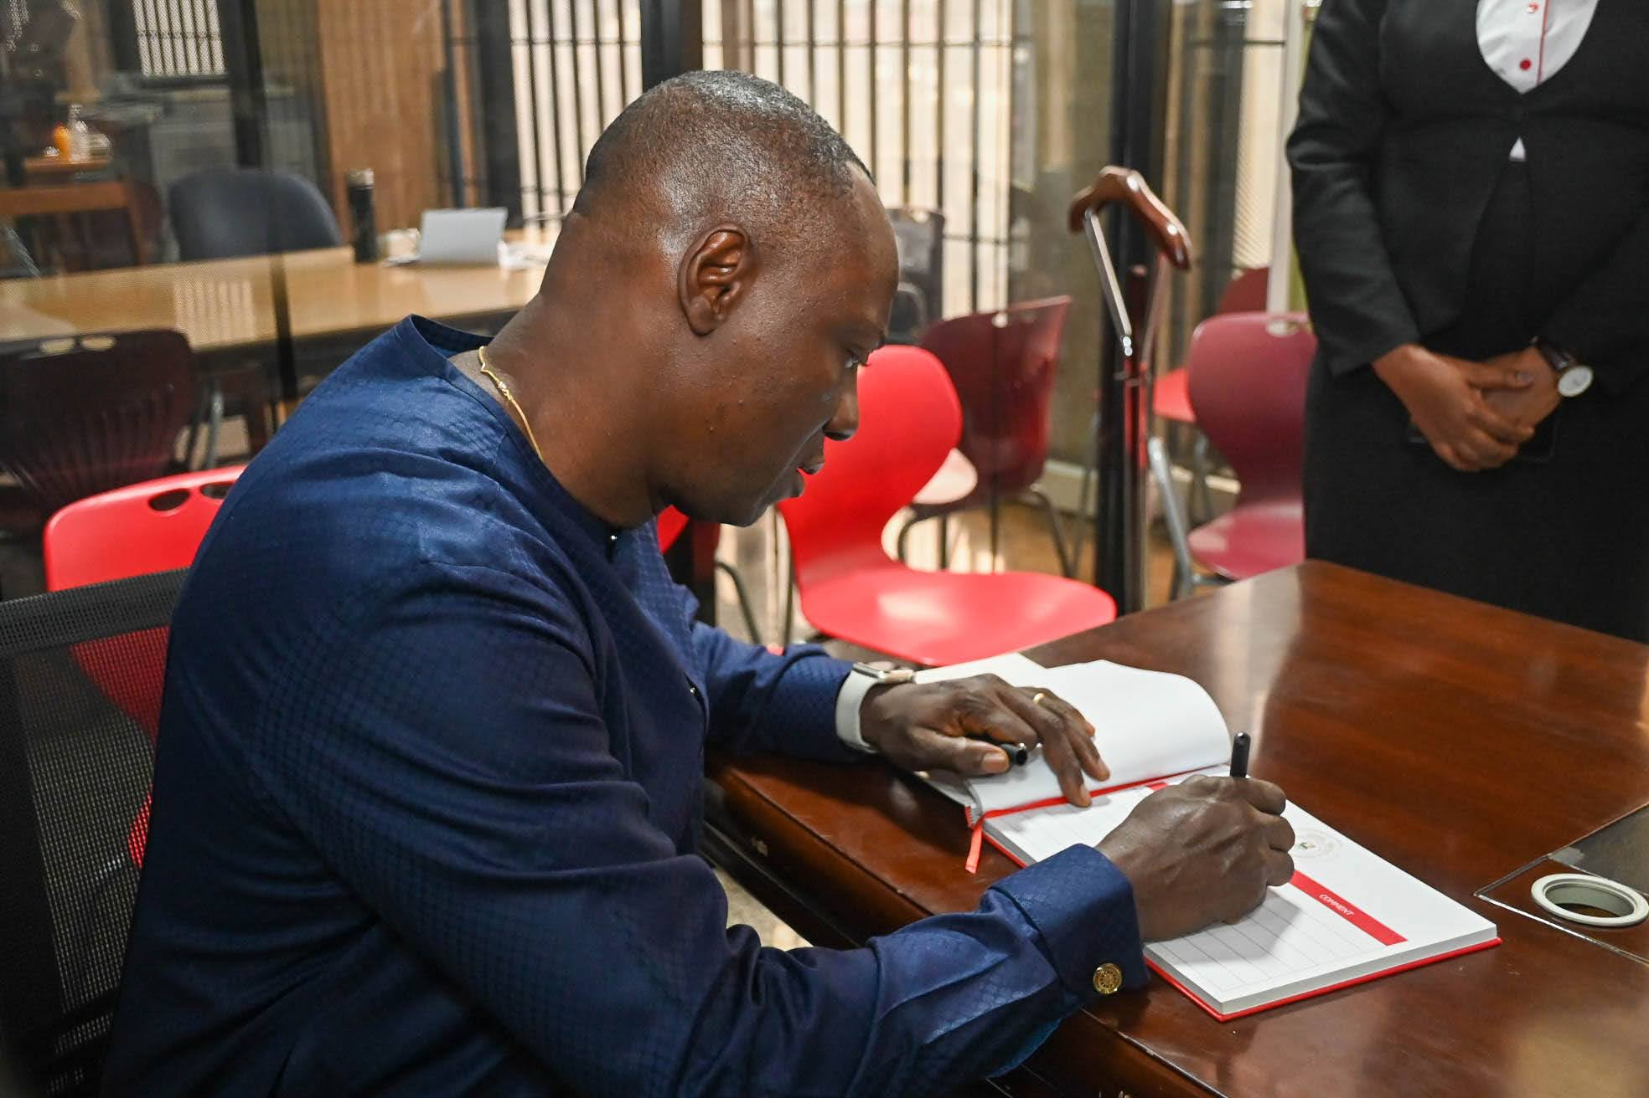

***Director-General - HRMO, Mr. Ansu Samuel Tucker, signing the visitors’ register at the Huduma Centre on behalf of the Sierra Leone Delegation.***

The delegation also took the opportunity to visit the Sierra Leone High Commission in Nairobi to brief the High Commissioner, Head of Chancery and other staff about the purpose of the study tour.

***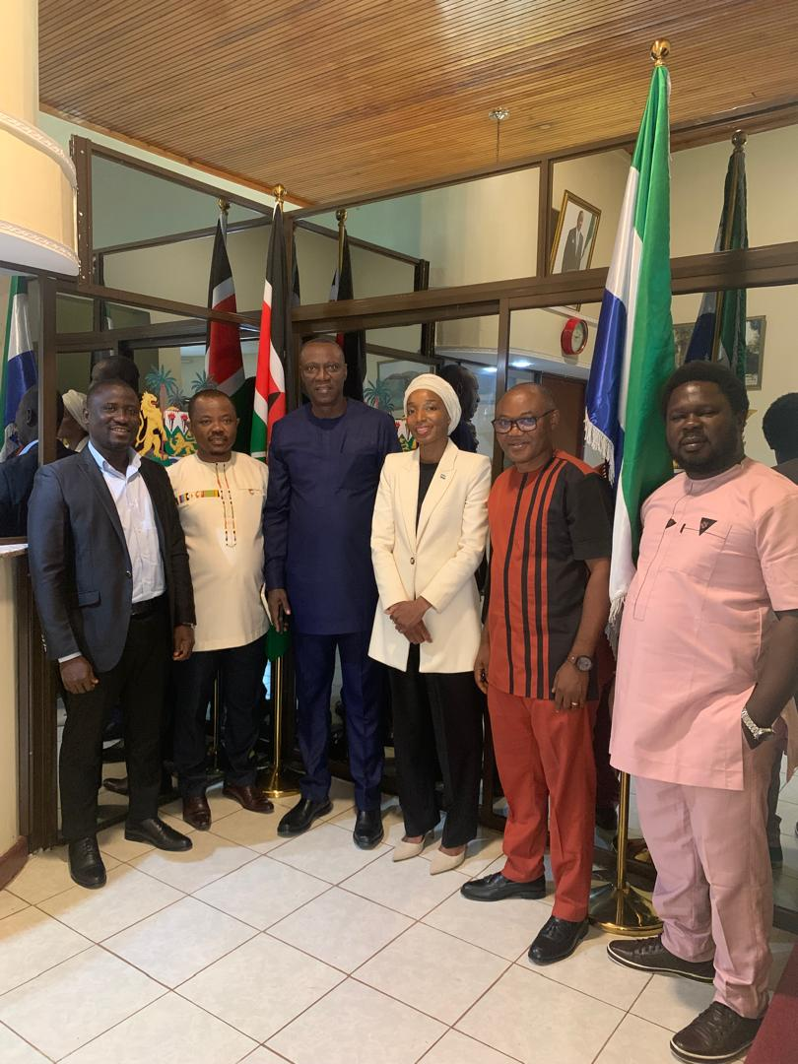***

***The Delegation with the High Commissioner at the Sierra Leone High Commission in Nairobi, Kenya.\****

# **SPECIFIC AREAS OF INTEREST**

The study tour primarily focused on the following, among others:

* 1. **Performance Management in Public/Civil Service**: Several interactive discussions were held on how the performance management system in the Kenya Public/Civil Service is implemented, the success stories, challenges and lessons learnt in the course of implementation. During the study tour, it was observed that the implementation of performance management system in Kenya Public/Civil Service is similar to what obtains in the Sierra Leone Civil Service. However, there are a lot of positives that the Sierra Leone Civil Service can borrow to enhance institutionalisation of performance management, particularly in the area of organisational work plan, performance rating, performance financing and instilling performance culture to enhance productivity in the Public/Civil Service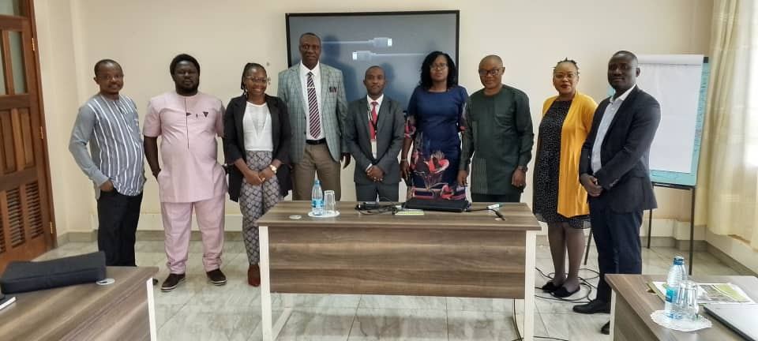***Facilitators for Performance Management from the Public Service Commission - Kenya, Kenya School of Government and the Delegation***

* 1. **Workload Analysis**: The area of staff rationalisation is a new vogue in the Sierra Leone Civil Service. To gain a practical knowledge and skills regarding workload analysis, a detailed interactive presentation was done in the following areas: steps and processes in conducting workload analysis; tools used in conducting workload analysis and challenges involved in implementing workload analysis initiatives. The key learning point from the presentations was that workload analysis can be better conducted in phases (Eg. by MDA or job family). The presentation has enhanced the delegation’s understanding of carrying out workload analysis.

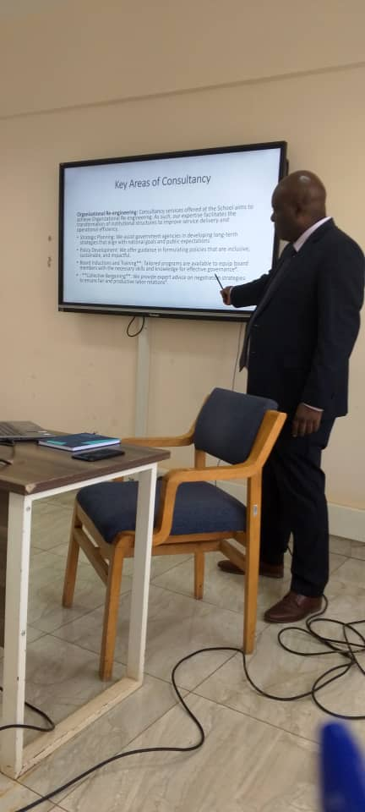

***Session on Workload Analysis***

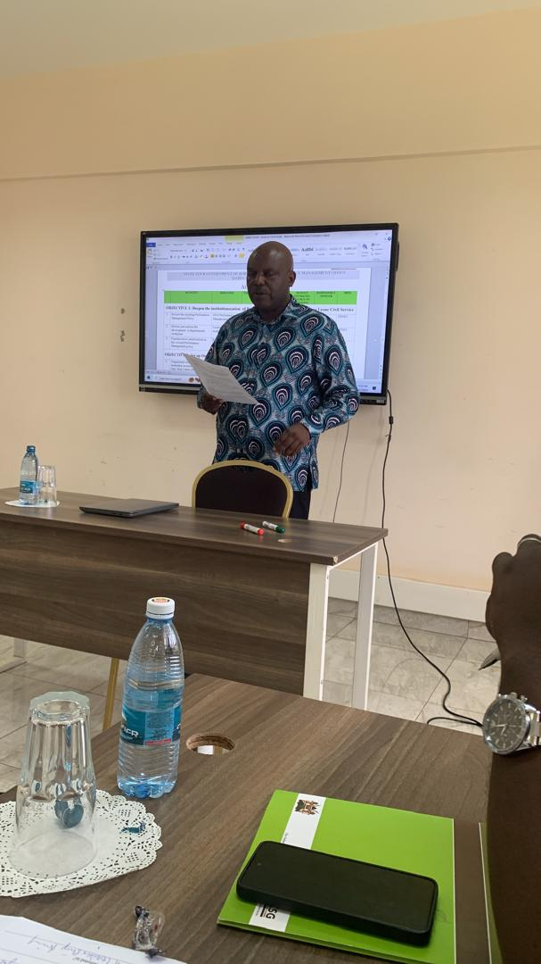

***Facilitating sessions on Work Planning***

* 1. **Strategic Leadership**: HRMO is very mindful of its leadership role in both the Civil and Public Service of Sierra Leone. Thus, several discussions and experience sharing were done on how transformational leadership drives organisational reforms and productivity in the Public/Civil Service. A practical example is the Kenya School of Government that has gone through several reforms to maintain excellence in service delivery. Another example is the setting up of Huduma Centres (One-Stop service delivery centres) for the provision of some essential public services with efficiency, speed and less bureaucracy such as national identity cards, police clearance, birth certificates, etc.

# **CHALLENGES ASSOCIATED WITH THE STUDY TOUR**

The study tour, despite the numerous successes in terms of experience shared and knowledge gained, was inundated with a couple of grave challenges, as outlined below:

1. there were delays in the approval process which affected the initial dates for undertaking the tours. These tours should have been undertaken between 2021 and 2022.
2. the three study tours were initially planned to be undertaken separately and at different locations/countries. However, due to delay in the implementation process, it became practically difficult to undertake them separately as originally planned because the cost had significantly increased.
3. due to the increase in cost, the actual number of staff who were supposed to have participated in the three study tours drastically reduced from twelve (12) to five (5) staff, with a significant reduction in the Daily Subsistence Allowance (DSA) from nine (9) days to six (6) days for each of the five staff.
4. the initial budget did not provide for obligatory costs such as airport security fee, cost of visa on landing and faculty facilitation fee for the host institution.

Despite these challenges mentioned above, a combined study tour was undertaken, which was a demonstration of high level of commitment, dedication and selflessness by the HRMO leadership and senior management in order to continue adding value and keep improving the Civil/Public service

# **LESSONS LEARNT**

The study tour was carried out through interactive sessions/discussions and visitations. Several lessons were learnt that could be of help in improving civil /public service delivery in Sierra Leone. Key amongst were:

* 1. **Building Strong Organisational Culture**: Leadership in the Civil/Public Service requires fostering a positive organisational culture that promotes transparency, accountability, integrity, and innovation. By sharing experiences during the study tour, the delegation gained insights into how to create a work culture that supports employee engagement, collaboration and continuous improvement.
  2. **Importance of clear objectives**: One of the fundamental lessons is the importance of setting clear and measurable objectives for organisational initiatives, such as performance management and workload analysis. Clear objectives help align effort towards common goals and provide a basis for measuring and evaluating success.

* 1. **Strategic Work Planning and Execution**: Effective strategic leadership involves not only developing a strategic plan but also executing efficiently. During the study tour, we learnt about best practices in strategic work planning, implementation, monitoring, and evaluation. Understanding how organisational goals can be cascaded to the individual level and aligned with day-to-day operations is crucial for successful executions.
  2. **Promoting Ethical Leadership**: Ethical considerations are paramount in Civil/Public Service leadership. Leaders must uphold high ethical standards, demonstrate integrity in decision-making, and act in the best interest of the public they serve.
  3. **Transparency and Accountability**: Transparency in processes and outcomes promote accountability in Civil/Public Service. Open communication about performance result, workload analysis initiatives, challenges faced, and actions taken built trust with stakeholders and encourages the culture of accountability.
  4. **Importance of Data Collection**: One of the crucial lessons learned is the importance of thorough data collection, which is essential for informed decision making. For instance, effective leadership, workload analysis and performance management rely heavily on accurate and comprehensive data. During the study tour, it was evident that meticulous data collection processes and analysis are essential for generating meaningful insight into organisational efficiency.
  5. **Leadership Commitment**: Strong leadership commitment at strategic and highest levels is essential for driving Civil/Public Service initiatives. Leaders play a pivotal role in championing performance management and workload analysis initiatives, setting expectations, providing guidance and fostering a supportive environment for implementation, including reward and sanction regimes.
  6. **Capacity Building**: Investing in building capacity within the Civil/Public service is key to enhancing productivity in service delivery. This includes staff capacity development and the right infrastructure to support the implementation of relevant training programmes. For example, in the public service, every public servant is required to undertake a five-day mandatory course at the Kenya School of Government.
  7. **Knowledge Sharing**: Learning from best practices both locally and internationally through study tours, facilitates knowledge sharing and cross-pollination of ideas. Exchanging experiences with other jurisdictions helps identify innovative solutions that can be tailored to local context. This was the case with this study tour as both sides benefited from each other’s ideas and experiences.
  8. **Innovation in the Public Service:** The setting up of the Huduma Centre is a classic example of decentralising public service delivery. It was learnt during the study tour that access to basic services such as the acquisition of birth certificate, police clearance, National Identity Cards, etc, was a huge problem for Kenyans. However, with the introduction of the Huduma Centre, access to the above services has become less difficult. Replicating this innovation in the Sierra Leone Public/Civil Service could help address the many challenges associated with public service delivery.
  9. **Stakeholders Engagement**: Effective performance management, staff rationalization and strategic leadership require active engagement with stakeholders at all levels. Engaging stakeholders including employees, managers, policy makers and the public fosters buy-in, collaboration and shared responsibility for achieving organisational goal/target.

# **RECOMMENDATIONS**

* 1. **Adherence to Project Timelines:** As stated above, the project implementation encountered significant delays which impacted the conduct of the study tours. Due to these delays, the three study tours were compressed into one; the number of days was reduced from 15 to 5; the number of participants reduced from 12 to 5. Thus, in future, project timelines should be adhered to to mitigate the challenges noted above.

* 1. **Follow-up Study Tour:** As a result of thelimitation encountered during the study tour, the delegation could not realise all of the objectives of the study tours, especially the visitation to relevant institutions to have hands-on experience on the conduct of workload and performance management. To address the limitations encountered, there is need for a follow-up study tour.
  2. **Setting up of a one-stop service delivery centre:** One of the takeaways of the study tour was the experience gained during the visit to Huduma Centre (One-Stop Service Delivery Centre), where certain essential services are centralised and delivered in real time. Such essential services include the issuance of birth certificate, National Identity Card, Police Clearance, payment of utility bills, etc. We strongly recommend that such One-Stop Centre be replicated in Sierra Leone to enhance effective service delivery.
  3. **Establishment of partnership/linkage with the Kenya School of Government:** The delegation strongly recommends that the leadership of the Sierra Leone Civil Service facilitate the establishment of partnership/linkage between Kenya School of Government (KSG) and the Sierra Leone Civil Service Training College (CSTC). As one of the flagship programmes of the Kenya Government, KSG has been positioned as a centre of excellence in the delivery of tailor-made training programmes for the public service, which could be beneficial to the growth of CSTC.
  4. **Re-enforce the development of Work Plans across MDAs:** The delegation learnt that work plans are integral part of performance management and productivity in the Civil Service. We recommend that this practice of developing and implementing work plans be re-enforced across MDAs for effective implementation, monitoring and evaluation of programmes and projects.

# **ANNEX 1: ACTION PLAN**

By the close of the study tour, the delegation developed an action plan detailing the next steps as contained in the table below:

| **NO.** | **ACTIVITY** | **BASELINE** | **TARGET/ BENEFICIARIES** | **TIME**  **FRAME** | **SOURCE OF FUNDING** | **RESPONSIBLE OFFICER(S)** | **LEAD INST.** |
| --- | --- | --- | --- | --- | --- | --- | --- |
| **OBJECTIVE 1: Deepen the institutionalization of Performance Management in the Sierra Leone Civil Service** | | | | | | | |
|  | Review the existing Performance Management Policy | 2016 Performance Management Policy | All Civil Servants in Grades 1 - 10 | July – Dec., 2024 | GoSL | Director, Performance Management | HRMO/ Cab. Sec./ MPAPA |
|  | Popularization /sensitization on the revised Performance Management policy | Revised PM Policy | All MDAs | Jan.– March, 2025 | GoSL | Director, Performance Management | HRMO/ Cab. Sec./ MPAPA |
|  | Review and enforce the development of departmental work plans | Existing departmental work plans of MDAs | All MDAs | Aug.– Dec., 2024 | GoSL | Director, Performance Management | HRMO/ MPAPA |
| **OBJECTIVE 2: Set up One- Stop Centre for Public Service Delivery** | | | | | | | |
|  | Engagement with the political leadership on need to establish One- Stop Centre for Service Delivery | NIL | Chief Minister, Minister - MPAPA, Minister- MoF, SP, HOCS, Chairman - PSC | July – Aug., 2024 | GoSL | DG, HRMO | HRMO |
|  | Develop Concept Note/Project proposal on the establishment of the One -Stop Centre | NIL | Chief Minister, Minister - MPAPA, Minister- MoF, SP, HOCS, Chairman - PSC | Aug. – Sept., 2024 | GoSL | DG, HRMO | HRMO |
|  | Engagement with Heads of MDAs and public service providers | NIL | Heads of MDAs and Service providers | Oct., 2024 | GoSL | Minister of MPAPA and DG, HRMO | MPAPA /HRMO |
|  | Undertake Study Tour to five Huduma Centres in Kenya | NIL | HRMO, MPAPA, MOF and MoCTI | Jan., 2025 | GoSL | Minister of MPAPA and DG, HRMO | MPAPA and HRMO |
|  | Prepare a Cabinet Paper based on the buy-in from the political leadership and study tour | NIL | Cabinet | Feb., 2025 | GoSL | DG, HRMO and Minister of MPAPA | HRMO and MPAPA |
|  | Hiring of Consultancy services for setting up of One – Stop Centre | NIL | GoSL | March, 2025 | GoSL | Minister of MPAPA and DG, HRMO | MPAPA and HRMO |
|  | Undertake field work, preparation of Consultancy report and validation | NIL | MDAs and Service Providers | Aug., 2025 | GoSL | Consulting Firm | MPAPA and HRMO |
|  | Setting up of Pilot One –Stop Centre for Public Service Delivery | NIL | GoSL and Public | Jan., 2026 | GoSL/ Donors | Chief Minister, Minister of MPAPA and DG, HRMO | OCM, MPAPA and HRMO |
| **OJECTIVE 3: Introduce Workload Analysis in the Human Resource Management of the Sierra Leone Civil Service** | | | | | | | |
|  | Review of the programme on the European Union support to introducing Workload Analysis in the Civil Service | EU approved programme estimate on Workload Analysis | HRMO | July, 2024 | EU/GoSL | Director, Management Services | HRMO |
|  | Develop a Concept Note for hiring of a Consultancy Firm | Draft Concept Note in place | HRMO | Aug., 2024 | EU/GoSL | Director, Management Services | HRMO |
|  | Hire a Consultant to conduct Workload Analysis | NIL | HRMO | Sept., 2024 | EU/GoSL | DG, HRMO | HRMO |
|  | Establish a Technical Working Committee for Workload Analysis | NIL | Civil Servants | Nov., 2024 | EU/GoSL | Director, Management Services | HRMO, Cab. Sec. MPAPA, PSRU and PSC |
|  | Undertake field work, preparation of Consultant report and validation | NIL | HRMO | Dec., 2024 | EU/GoSL | Consultant | HRMO, Cab. Sec. MPAPA, PSRU and PSC |
|  | Pilot the introduction of Workload Analysis at HRMO | NIL | HRMO | Feb., 2025 | EU/GoSL | Director, Management Services | HRMO |
| **OJECTIVE 4: Foster Transformational Leadership across the Civil/Public Service to drive Government Agenda** | | | | | | | |
|  | Conduct quarterly leadership seminars for all Permanent Secretaries, Professional Heads, Heads of Departments and Directors | Existing periodic leadership meetings for Permanent Secretaries and Professional Heads | Permanent Secretaries, Professional Heads, Heads of Departments and Directors | End of third quarter, 2024 | GoSL | DG, HRMO, Minister of MPAPA, Cab. Sec. | HRMO, MPAPA and Cab. Sec. |
|  | Conduct half yearly leadership seminars for Deputy Secretaries/ Deputy Directors and Assistant Directors | Nil | Deputy Secretaries/ Deputy Directors and Assistant Directors | Jan., 2025 | GoSL | DG, HRMO, Minister of MPAPA, Cab. Sec. | HRMO, MPAPA and Cab. Sec. |

***Note: A detailed strategy to achieve the implementation of this Action Plan should be developed by the Human Resource Management Office.***

# **ANNEX 2: PROGRAMME OF THE STUDY TOUR**

**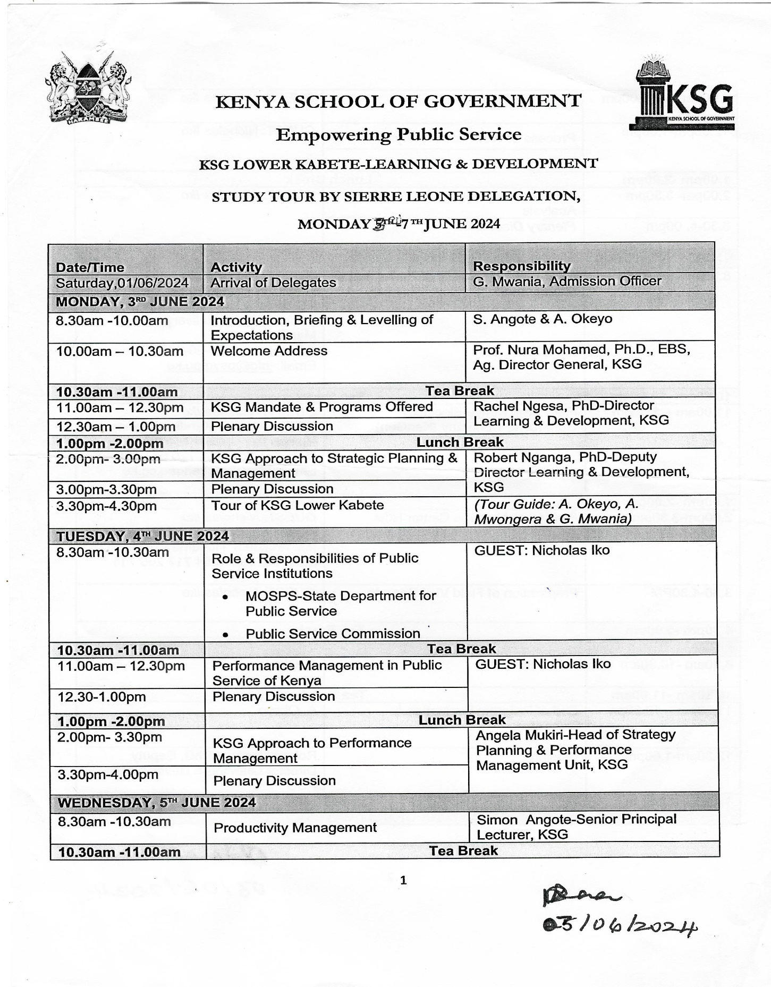**

**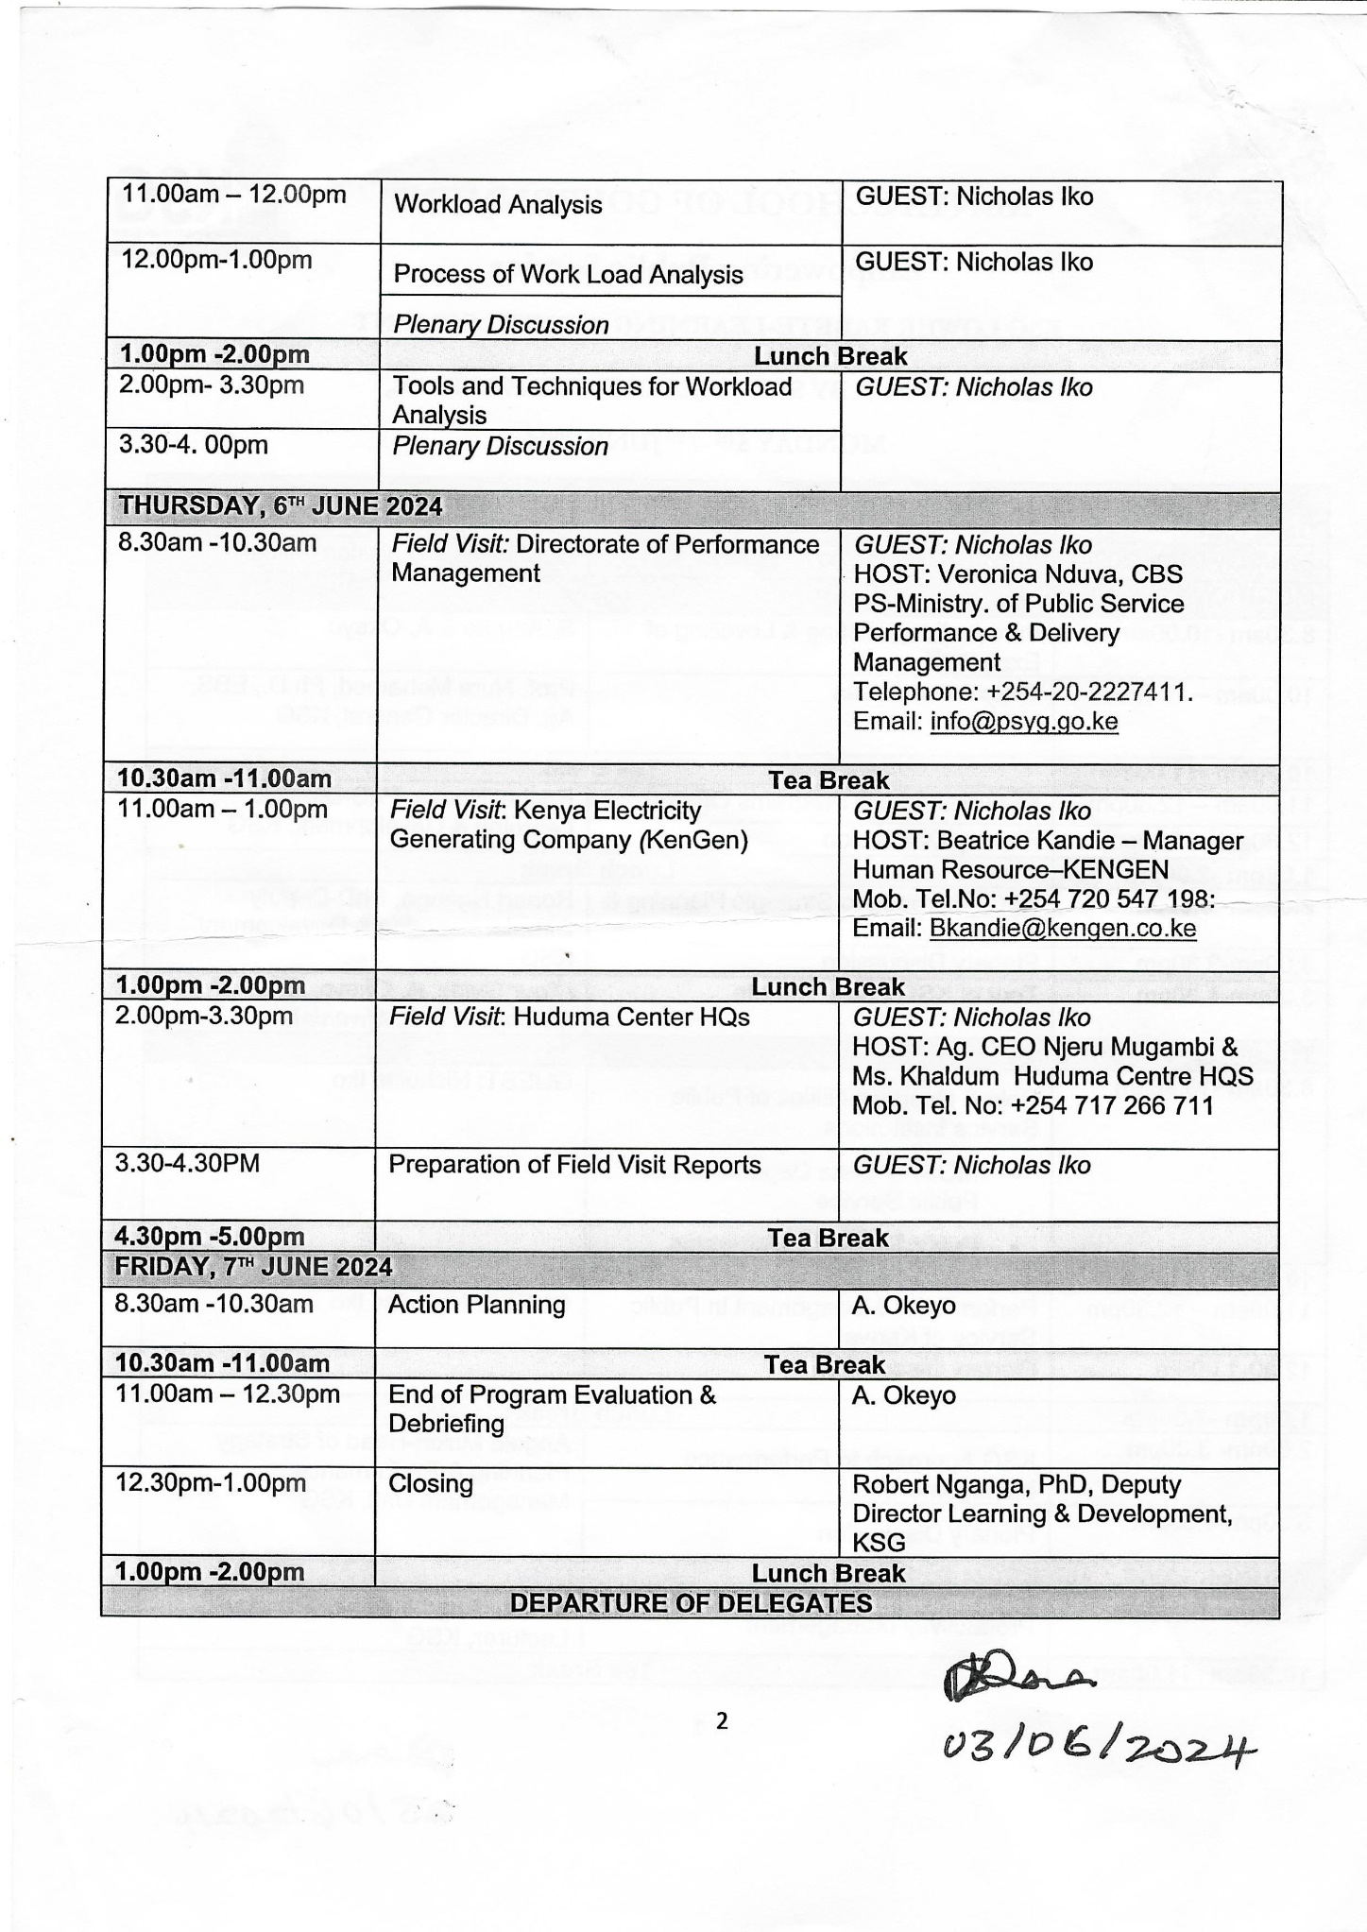**

# **ANNEX 3: ATTENDANCE LIST**

**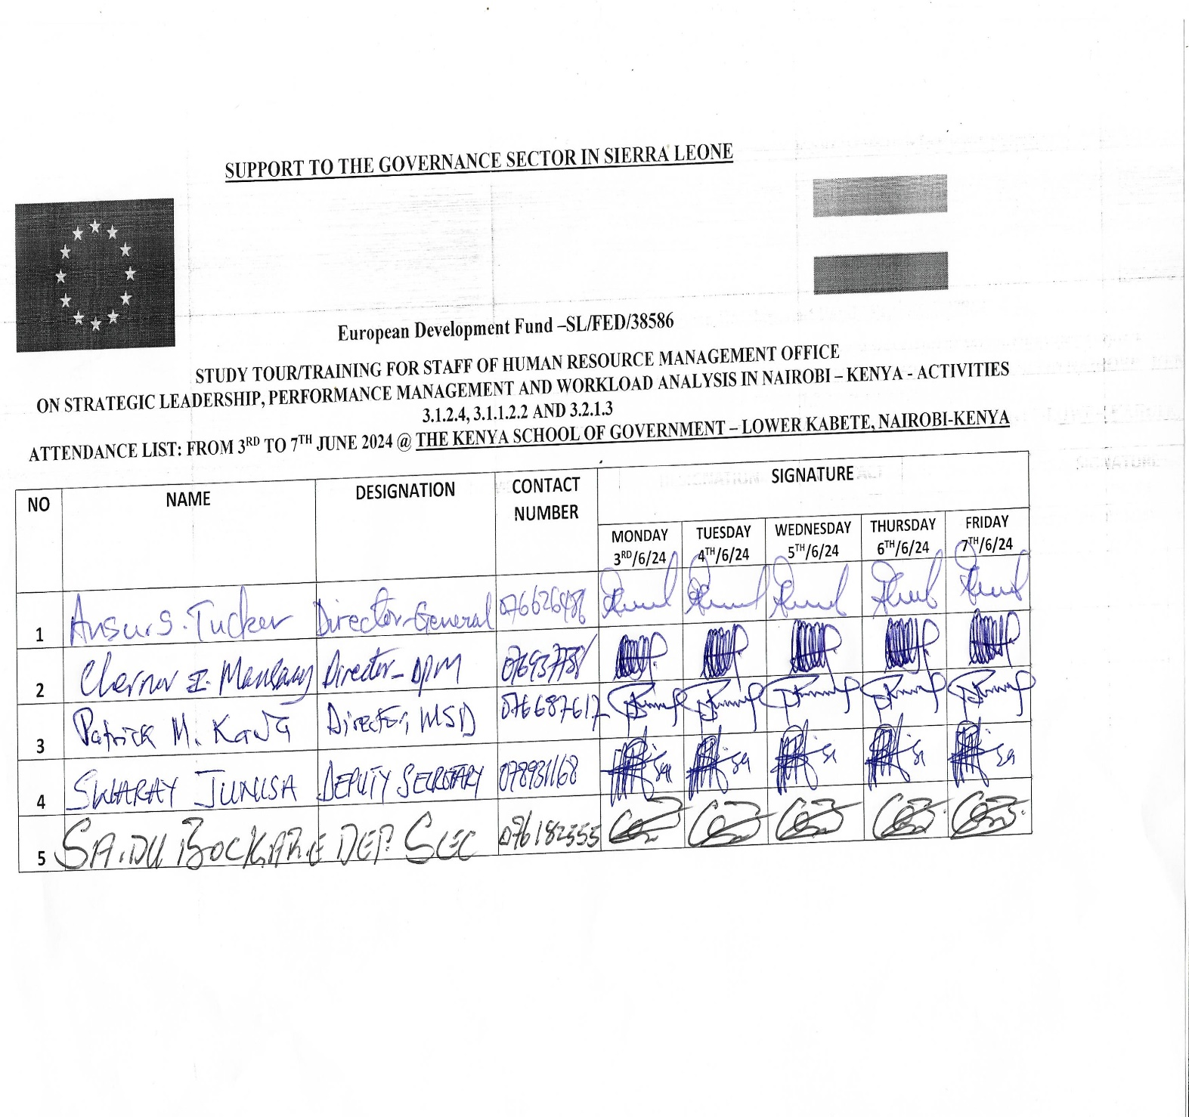**

# **PHOTO PAGE**

|  |  |
| --- | --- |
| ***C:\Users\DELL\Downloads\WhatsApp Image 2024-06-05 at 14.37.22 (2).jpeg*** | |
| ***Posing with our Programme Coordinator and Memebers of the facilitation team*** | |
| C:\Users\DELL\Downloads\ELD_3755.jpg | C:\Users\DELL\Downloads\ELD_3668.jpg |
| ***Kenyan Affordable Housing Service Centre*** | ***Meeting with the manager of the Huduma Centre*** |
| C:\Users\DELL\Downloads\WhatsApp Image 2024-06-10 at 17.37.46.jpeg | C:\Users\DELL\Downloads\WhatsApp Image 2024-06-07 at 12.15.37.jpeg |
| ***Having Dinner organised by the Director- General, Kenya School of Government*** | ***Tea Time*** |
| C:\Users\DELL\Downloads\ELD_3780.jpg  ***Cross session of staff of the Huduma Centre*** | |
| C:\Users\DELL\Downloads\WhatsApp Image 2024-06-09 at 07.47.52.jpegC:\Users\DELL\Downloads\WhatsApp Image 2024-06-09 at 07.47.49.jpeg  ***Waiting to Return to Freetown at the VIP Lounge, Jomo Kenyatte International Airport*** | |
| C:\Users\DELL\Downloads\WhatsApp Image 2024-06-04 at 14.35.34.jpeg  ***With facilitators on Leadership and Performamnce Management*** | |
| ***C:\Users\DELL\Downloads\WhatsApp Image 2024-06-18 at 15.59.03.jpeg***  ***At the Departure Lounge, Lungi International Airport*** | ***C:\Users\DELL\Downloads\ELD_3701.jpg***  ***Manager, Huduma Centre*** |
| C:\Users\DELL\Downloads\ELD_3715.jpg  ***Manager of Huduma Centre in conversation with the Director General, HRMO*** | C:\Users\DELL\Downloads\ELD_3726.jpg  ***Service Charter of the Huduma Centre*** |