

DIRECTORATE OF PERFORMANCE MANAGEMENT HUMAN RESOURCE MANAGEMENT OFFICE

JANUARY, 2024

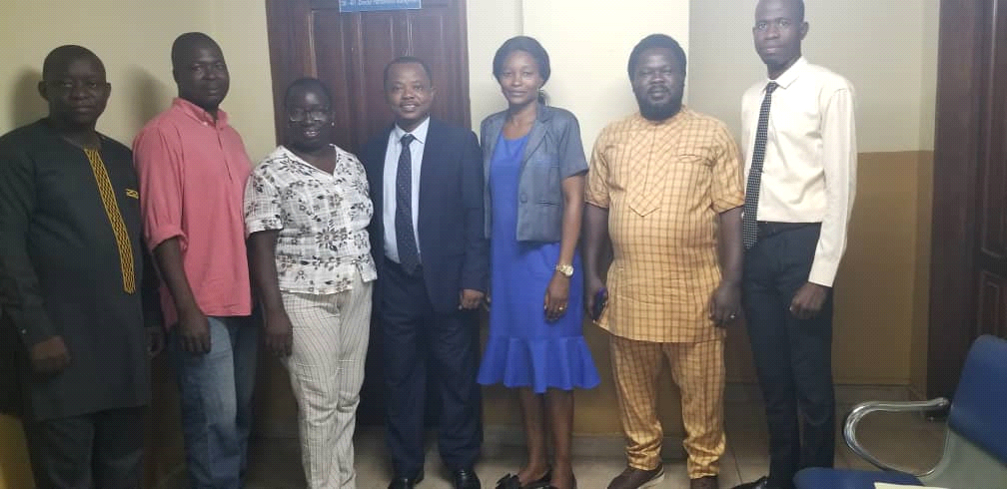

2023 ANNUAL report

**Table of Content**

Introduction………………………………………………………………………………………….……1

Staffing Situation ……………………….……………………………………………………….….….1

Activities Implemented/Achievements....……………………………………………………2

Performance Target Setting………………………………………………………………………..3

Facilitation of 2022 IPAS Mid and Annual Reviews ……….…………………………….3

Monitoring of IPAS Implementation……….…..………………………………………………3

On-Site Training on IPAS for MDAs………………………………………………………………4

Review of IPAS Compliance for Officers on Probation………………………………….5

Verification of Annual Vacation Leave for IPAS Compliance………………………….6

Special Monitoring of IPAS Implementation for Administrative Staff …………..6

Assessment of Civil Servants in Grades 11 and above…………………………..….…..7

Provision of Technical Support on the Review of the Code……………………………7

Provision of Technical Backstopping to LGSC………………………………………………..8

Provision of Technical Support to the EU-MAPE M&E Consultan…………………..9

Collaboration with CSTC on Performance Management Trainings…………………9

Challenges……………………………………………………………………………………………………10

Recommendations……………………………………………………………………...……………….11

Next Steps for 2024……………………………………………………………………..……………….12

**1. Introduction**

The Human Resource Management Office (HRMO) comprises eight directorates that function to support the Director-General in the day-to-day management of the Civil Service. The Directorate of Performance Management is one of the eight directorates which is primarily responsible to perform among others, the following functions:

* Manage the Individual Performance Appraisal System (IPAS) in the Civil Service in compliance with the applicable policies and procedures.
* Design and implement a Monitoring and Evaluation System for IPAS including testing and applying the appropriate tools and framework.
* Facilitate knowledge building and knowledge sharing in the Civil Service on Performance Management in general and Individual Performance Appraisal in particular.
* Collaborate with Cabinet Secretariat and Office of the Chief Minister on Performance Management System more particularly for senior officers in Grades 11 and above and Ministers including Heads of parastatals.

This Report represents details of activities carried out by the directorate towards the implementation of the Individual Performance Appraisal System (IPAS) for Civil Servants in Grades 1 to 10 across Ministries, Departments and Agencies (MDAs) and the collaborative engagements with Cabinet Secretariat and Office of the Chief Minister towards the institutionalisation of performance management culture in the Civil/Public Service for effective and efficient service delivery.

**2. Staffing Situation**

The directorate has a very lean staff strength, comprising a total of five personnel and is often supported by the Assistant Monitoring and Evaluation Director in carrying out most of its functions. In the last quarter of the year under review, an intern (Mohamed Bellay) from Fourah Bay College was also assigned to the directorate. Below are the current staff of the directorate:

1. Mr. Chernor I Mansaray – Director
2. Mr. Swaray Junisa - Deputy Secretary
3. Ms. Mabinty Sankoh - Senior Assistant Secretary
4. Mrs Christiana A. Kamara - Senior Data Entry Clerk.
5. Saidu Kamara – Driver

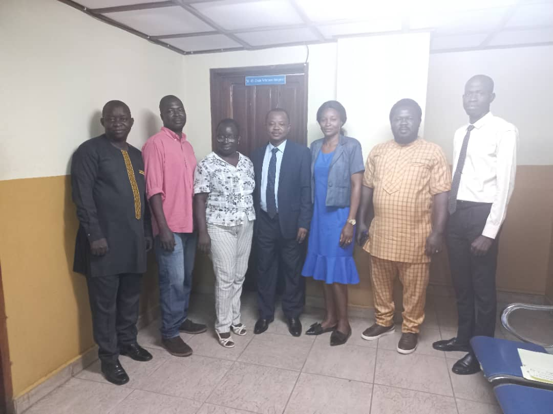**Performance Management Directorate Staff, the Asst. M&E Director and the Intern**

**3. Activities Implemented/Achievements**

The year 2023 was very challenging in terms of availability of funds to implement planned activities. The directorate did not receive any funding support from GoSL to carry out planned major activities that had financial implications due to the paucity of resources. However, through the innovative and charismatic leadership of the directorate, coupled with committed staff, the directorate was able to implement some activities, which created significant impact towards institutionalizing performance management system in the Civil Service, as highlighted below:

**3**.**1 Facilitation of 2023 Performance Targets Setting for Civil Servants in Grades 1 to 10 across MDAs**

The Performance Management Policy clearly states that Civil Servants including Contract Staff are expected to set their individual targets in agreements with their supervisors on or before the 15th of January of each appraisal year. In tandem with this policy provision, the directorate facilitated Individual Performance Targets Setting for Civil Servants in Grades 1 to 10 across MDAs. To this end, several correspondences signed by the Director General in respect of performance target setting and sanctions for noncompliance were sent to heads of MDAs in December 2022 and January 2023 respectively. This was done to remind heads of MDAs about their roles and responsibilities towards the implementation of IPAS. As a result of the prompt facilitation, backed by follow up visits, the compliance rate for target setting increased tremendously across some MDAs in 2023.

**3.2 Facilitation of 2023 IPAS Mid-Year and Annual Reviews Across MDAs**

The implementation of Individual Performance Appraisal System is done in phases. Civil servants are required to set their targets at the beginning of the appraisal year, conduct Mid-year review with their supervisors after six months of implementation and also conduct Annual review at the end of the same appraisal period. However, in order to ensure that MDAs comply with the appraisal process and do due diligence, the directorate facilitated both Mid-Year and Annual IPAS reviews across MDAs. To this end, most MDAs were able to conduct both reviews for 2023. However, it must be noted that there was a decline in the level of compliance for the 2023 Mid-year review compared to 2022 Mid-year review.

**3.3 Monitoring of IPAS Implementation across MDAs**

Monitoring of IPAS implementation is a critical component of the Performance Management System in the human resource management functions in the Sierra Leone Civil Service. The main objective of IPAS is to ensure the highest level of accountability at both individual and institutional levels, bringing about a shared understanding of what is to be achieved, how that is to be achieved and how achievement can be rewarded and non- achievement sanctioned.

During the period under review, the directorate conducted two major monitoring exercises in the Western Area to track progress on IPAS implementation. The first monitoring exercise to track progress on the conduct of 2022 Annual reviews and setting of Individual Performance targets for 2023 by Civil Servants in grades 1 to 10 across MDAs was conducted in February 2023. A detailed monitoring report for this exercise was submitted to the Director General for further directives. Also, another monitoring exercise on IPAS implementation was conducted in August 2023 across MDAs. The objective of this monitoring exercise was to track progress made by MDAs regarding the level of compliance in the Mid-Year reviews conducted by supervisors and their appraisees. The findings presented after this exercise shows that more Civil Servants conducted the Mid-Year review as against those that set their targets at the beginning of the year. The detailed report was submitted to Director General and specific portions sent to MDAs. This resulted in some positive feedback from MDAs whose performance was not encouraging.

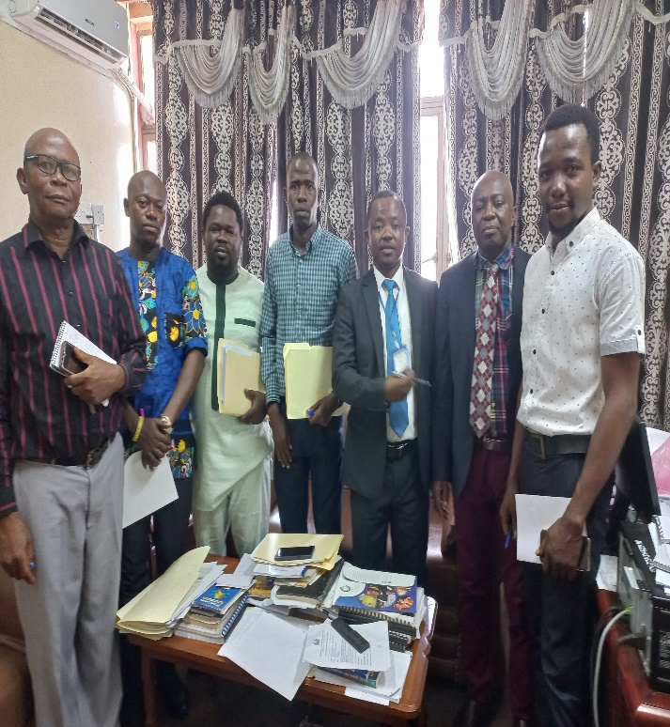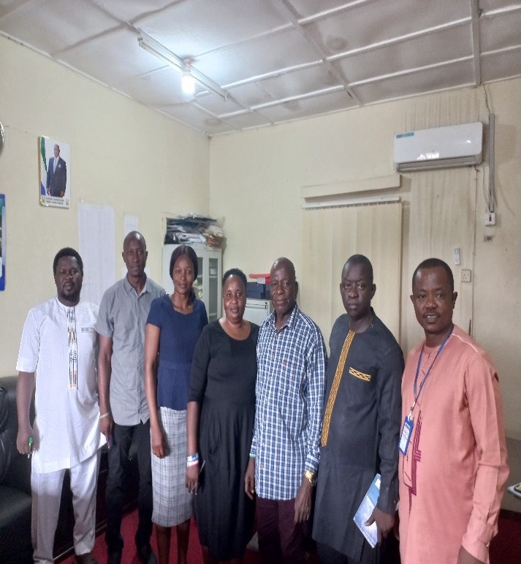

**Monitoring Team at MLGCA Monitoring Team at MSW**

**3.4. Conduct of IPAS On-Site Training for MDAs**

Given the realization of the paucity of funds and that HRMO alone cannot afford to train all Civil Servants due to huge financial implications, the directorate resorted to providing on-site tailor-made training for some MDAs. The tailor –made training focused primarily on the core mandates of each MDA and the specific duties performed by the officers. In 2023, a total of five (5) MDAs namely: Ministry of Technical and Higher Education, Office of the Administrator and Registrar General, Office of the Vice President, Ministry of Finance, and the Government Printing Department benefitted from on-site trainings conducted by the directorate in the Western Area. A total of **320** Civil Servants comprising junior, middle, and senior officers were trained across the five MDAs. Of the **320** trained, **115** were female whilst **205** were male. The impact of the on-site trainings conducted was clearly evident in the compliance ratings of these MDAs as their major challenges with regards setting targets and conducting appraisals were addressed.

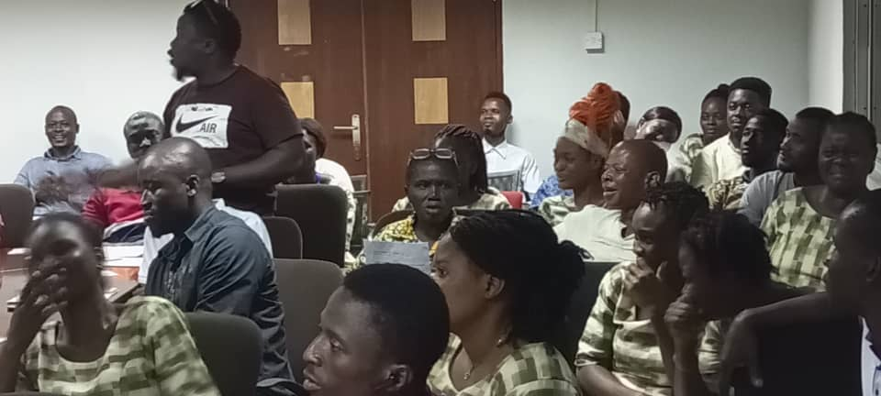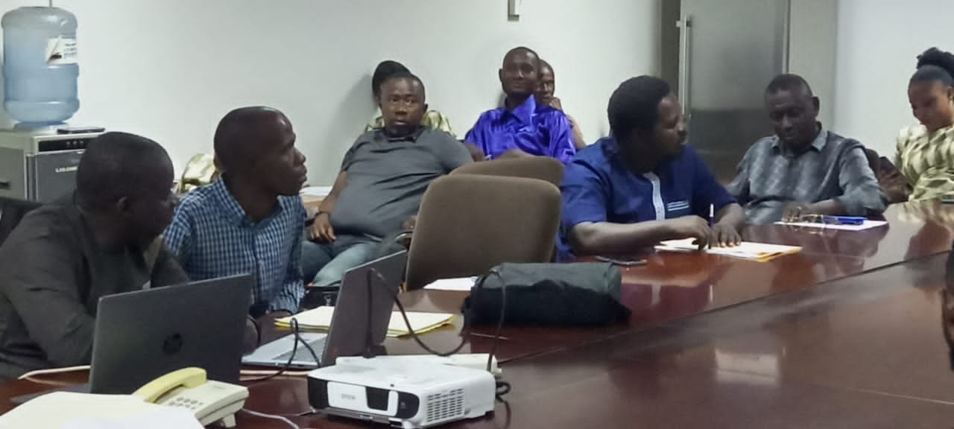

**On-site Training at the Government Printing Department**

**3.5. Review of IPAS Compliance for Officers on Probation**

**Rule 2.42** of the Civil Service Code, Regulations and Rules requires officers on probation to submit their progress reports (now their two years IPAS records) in order to determine their suitability for the confirmation of their appointment in the Service. Thus, as of 5th December 2023, a total of **774** submissions of progress report/IPAS forms were made by heads of MDAs in respect of their officers for confirmations. The directorate reviewed all submissions received and a total of **689** Officers fulfilled IPAS compliance while **85** Officers did not comply. The reviewed IPAS forms were duly submitted to the Director, Recruitment and Selection for further necessary action. This collaboration between the Directorates of Performance Management and Recruitment and Selection has given more prominence to performance appraisal system in the Civil Service.

**3.6. Verification of Annual Vacation Leave Applications for IPAS Compliance for Civil Servants in Grades 1 to 10**

Setting individual performance targets at the beginning of the year by all Civil Servants is mandatory. In order to ensure full compliance with IPAS directives, the Director-General had earlier directed that all Civil Servants must at least set individual targets as part of the eligibility criteria for the Annual Vacation Leave (AVL). In that respect, the directorate was inundated with AVL application requests from the Directorate of Staff Welfare and Employee Relations to verify officers who had set their individual targets for 2023. Those who set their performance targets had their requests processed while those who did not, were not approved. The motivation behind this action was to ensure that officers were held to account for their stewardship and add value to the work they perform.

**3.7. Special Monitoring of IPAS Implementation for Administrative Staff**

In September 2023, based on the directive of the Director Genera, the directorate for the second time ever, conducted a special performance appraisal monitoring exercise in respect of all Senior Assistant Secretaries and Acting Deputy Secretaries across MDAs. The objective of the exercise was to track progress of IPAS implementation for the above categories of Civil Servants covering the period 2020-2022. This exercise was successfully completed and the findings submitted to the Director General for necessary action.

**3.8. Collaboration with Cabinet Secretariat and Office of the Chief Minister on Performance Management**

Performance management is one amongst the many cross cutting issues that require effective collaboration across government in order to achieve the desired results. As you are aware, Cabinet Secretariat is responsible for assessing the performance of Civil Servants in Grades 11 and above in collaboration with the Human Resource Management Office. During the period under review, the directorate collaborated with Cabinet Secretariat in counter-signing the Performance Tracking Tables (PTTs) of officers in Grades 11 and above and also took part in the review processes of those staff. Similarly, the Office of the Chief Minister oversees /assesses ministerial and heads of parastatals performance contracts. To achieve that, several collaborative and fruitful meetings were held all gearing towards institutionalising performance management culture in the Civil /Public service for effective and efficient service delivery. The directorate actively took part in all the collaborative meetings held.

**3.9. Provision of Technical Backstopping in the Review of the Civil Service Code, Regulations and Rules**

The Civil Service Code, Regulations and Rules which came into existence in 2011 to replace the General Orders serves as the code of instruction on personnel matters in the Civil Service. Rule 13:20 of the Code requires that the document be reviewed every 5 years through a process to be led by the Director General. During the review process, the directorate provided technical support throughout the entire consultative and validation process thus far, by being part of the team set up by Director-General and Consultant that traversed across all the districts, and also led in the power point presentations on the Code on behalf of the Director General.

**3.10. Provision of Technical Backstopping to Local Government Service Commission in Drafting Performance Appraisal tools for Core and Auxiliary staff of Local Councils**

In modern day management/administration, performance management is critical as it has proven to be a good managerial tool. The Local Government Service Commission being the body responsible to provide oversight functions for the twenty-two (22) Local Councils nation-wide, needed to provide the councils with staff performance appraisal tools objective enough to measure the performance of council staff. To this end, the Commission solicited the technical support of the directorate through the Director-General. In the quest to achieve this, the directorate actively participated in the regional consultative engagements undertaken by the Commission to elicit the views of council staff on the nature and scope of the appraisal tools they would prefer. This was followed by another successful regional consultation to validate the draft staff appraisal tools.

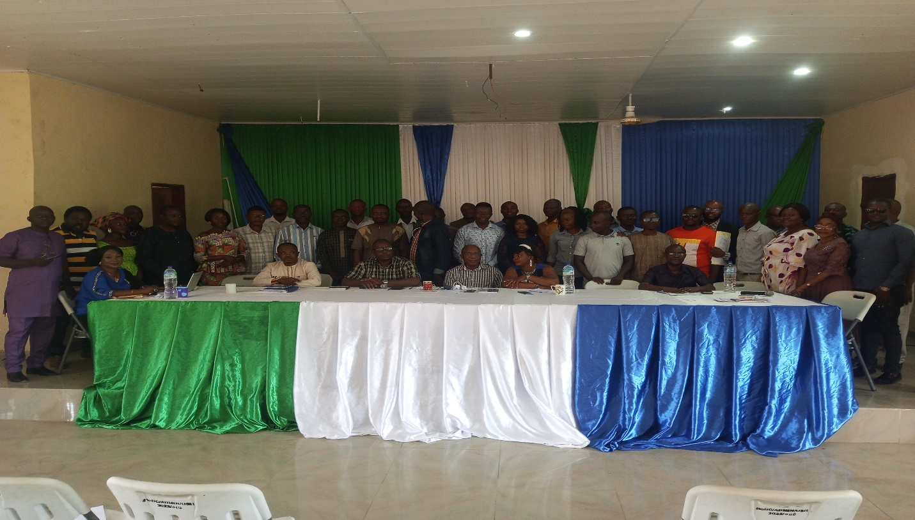

**Group photo of the Regional Consultation in the Southern region (Bo)**

**3.11. Provision of Technical Support to the EU-MAPE M&E Consultant on the Assessment of the M&E Systems of Key Reform Institutions in the Civil Service**

A consultant was hired under the EU-MAPE project to carry out a baseline assessment of the current monitoring and evaluation system in key reform institutions in the Civil Service, with specific focus on Public Service Commission (PSC) and Human Resource Management Office (HRMO). Her terms of reference also included the development an M&E Training Plan and Curriculum for the key reform entities. In this regard, the Director and Deputy Secretary of the directorate together with the Asst. M&E Director have been part of the team working closely with the Consultant in carrying out the baseline assessment as well as the other components of the consultancy. So far, the baseline survey has been done and work is at an advanced stage to develop the M&E Curriculum and Training Plan.

**3.12. Collaboration with Civil Service Training College on Performance Management Training for Senior Civil Servants in Grades 11-13**

As part of its nation-wide skills development training interventions for Civil Servants, the Civil Service Training College (CSTC) organised a two-weeks long training on Performance Management for thirty (30) officers in Grades 11-13 in December 2023. The directorate supported management of CSTC in the development of the training content and also served as co-facilitator in the delivery of the training. The outcome of the training revealed the need for such training interventions for very senior officers as part of effort to institutionalize performance management in the Civil Service.

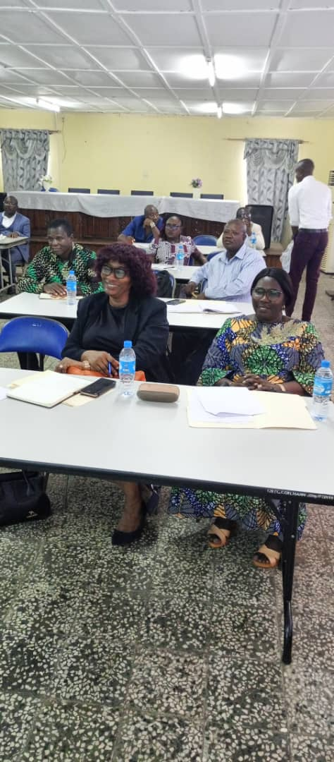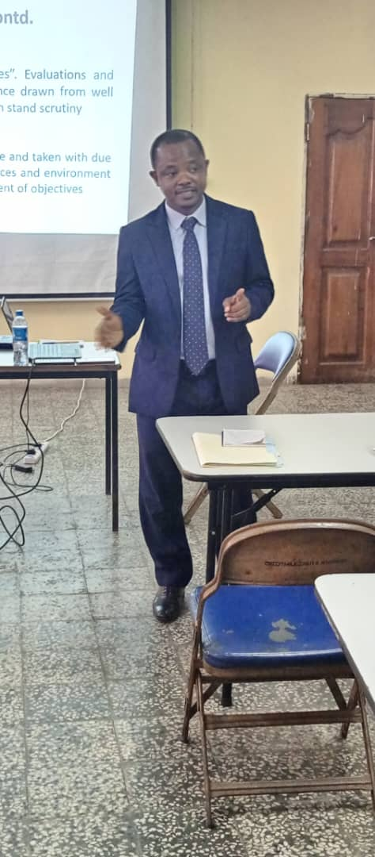

**4. Key Challenges**

In the performance of its functions during the period under review, the directorate encountered numerous challenges as highlighted below:

1. Non-availability of funds from GoSL budgetary allocation to implement planned activities for the entire 2023 financial year. This tremendously inhibited the directorate from undertaking some of its planned programmes and activities during the period under review.
2. Lack of the required level of commitment on the part of some MDAs in setting targets and conducting appraisals. Despite the gains made over the years in institutionalize performance management in the Civil Service, there are some MDAs whose level of compliance is still below satisfactory as seen in the recent reports of the Mid-year and Annual reviews undertaken.
3. Weak capacity/knowledge on IPAS for a good number of Civil Servants. This continues to undermine the level of compliance required from officers. Thus, continuous capacity building through training, mentoring and couching can be useful in addressing this bottleneck.
4. Weak leadership support in some MDAs in the institutionalization of IPAS poses another grave challenge in advancing the culture of performance across the Civil Service. The support of heads of MDAs and other staff in authority (e.g. Supervisors) is pivotal in ensuring that supervisees give IPAS the attention it deserves. When the leaderships of MDAs own the IPAS process and make it part of their priorities, institutionalizing it becomes less challenging.
5. Lack of tangible rewards for good performance and sanctions for poor performance. When high performers are recognized and rewarded, while poor performers are also identified and sanctioned accordingly, the Civil Service performance landscape will be viewed differently and compliance would become the norm.
6. Lack of adequate funds to implement set targets by majority of staff across MDAs year in year out poses another critical challenge to the overall objective of IPAS. While some targets may not have financial implications, a good number of others require adequate and timely funding for implementation.

**5. Recommendations**

* Ensure the timely provision of adequate funds for capacity building on IPAS for staff across all grades in the Civil Service. Regular training interventions and on-sight training activities that require funding to be carried out across the board must not be overlooked if the narrative is to improve significantly.
* Commence the full-blown implementation of the reward and sanction regime in order to recognise and reward outstanding performers while at the same time call out and sanction poor performers. This is a crucial part of achieving the performance result we all yearn for.
* The leadership of the Service to ensure that the annual outcome of IPAS assessment/appraisal serves as one of the primary bases to determine promotion, transfers, training and dismissal among others, in order to further deepen and strengthen the culture of performance management in the Civil Service.
* The leadership of HRMO should strongly advocate with the Head of the Civil Service, to ensure that officers in Grades 11 and above, include in their PTT as a target, 100% compliance with PAS directives for all staff under their supervision for each appraisal year.
* HRMO in consultation with the Head of the Civil Service should take punitive measures against supervisors who fail to provide the necessary support to their appraisees in relation to the IPAS process.
* Expand the scope of IPAS implementation monitoring visits to cover not just MDAs in the Western Area but the districts where the greater majority of Civil Servants work. This can help to further strengthen the culture of performance management in the Civil Service.

**6. Next Steps**

1. Preparation of the Director’s Performance Contract (PTT) and Setting of Targets for other staff in the directorate for 2024 appraisal year
2. Carry out monitoring visits across MDAs for 2023 Annual IPAS appraisal and the Setting of Targets for 2024
3. Conduct refresher IPAS training for staff of HRMO in Grades 1-10
4. Carry out monitoring visits across MDAs for the conduct of 2024 Mid-year and Annual IPAS reviews
5. Conduct on-site/tailor-made IPAS trainings based on MDAs request
6. Undertake regional IPAS training for the Northern region
7. Undertake Study Tour on Performance Management in any African country
8. Support the convening of the quarterly Civil Service Leadership meetings
9. Collaboration with Cabinet Secretariat to counter-sign the PTTs of officers in Grades 11 and above
10. Special IPAS monitoring of health facilities in the Western Area